

**BỘ CÔNG THƯƠNG**

**TRƯỜNG ĐẠI HỌC CÔNG NGHIỆP TP. HỒ CHÍ MINH**

**KHOA CÔNG NGHỆ THÔNG TIN**

**----🙣🕮🙡----**

**EXERCISE REPORT**

***Đề tài: RECYCLING SYSTEM***

***Instructor guides* : VÕ VĂN HẢI**

***Group*  : 2**

***List Member* :**

***Ngô Thiên Phú - 20087651***

***Ngô Quang Thảo - 20117861***

***Lê Quốc Đạt - 20116521***

***TP.HCM, ngày 20 tháng 5 năm 2024***

**MENU**

1. SYSTEM REQUIREMENTS: 4

1.1. Quotation: 4

1.1.1. Website Quotation Request: 4

1.1.2. Device Information Entry: 4

1.1.3. Quotation Calculation and Display: 4

1.1.4. Accept or Decline Quotation: 4

1.2. Device Transfer to the Recycler: 4

1.3. Device Shipping Process: 4

1.3.1. Shipping Request: 4

1.3.2. Preparation and Packaging: 5

1.3.3. Sending the Device: 5

1.3.4. Notification and Status Update: 5

1.4. Device Re-Evaluation: 5

1.4.1. Functionality Check: 5

1.4.2. Physical Condition Assessment: 5

1.4.3. Recycling or Disposal Decision: 5

1.5. Payment Process: 6

1.5.1. Evaluation Result Confirmation: 6

1.5.2. Payment Amount Determination: 6

1.5.3. Customer Notification: 7

1.5.4. Payment Process: 7

1.5.5. Transaction Recording: 7

1.6. Recycling Ticket Statuses: 7

2. USE CASE DIAGRAM 8

3. CLASS DIAGRAM 8

4. SYSTEM ARCHITECTURE 9

4.1 Advantages of Service-Based Architecture 10

4.1.1 Flexibility and Scalability: 10

4.1.2 Ease of Maintenance and Upgrades: 10

4.1.3 Enhanced Fault Tolerance: 10

4.1.4 Independent Development Teams: 10

4.1.5 Diverse Technologies: 10

4.2 Disadvantages of Service-Based Architecture 10

4.2.1 Complexity: 10

4.2.2 Performance and Latency: 10

4.2.3 Data Consistency: 11

**RECYCLING SYSTEM**

# 1. SYSTEM REQUIREMENTS:

The recycling system includes the following main functions:

## 1.1. Quotation:

### 1.1.1. Website Quotation Request:

Users can access the recycling company's website to request a quotation for their old electronic devices. The website provides an easy-to-use and user-friendly interface for users to enter information about their devices.

### 1.1.2. Device Information Entry:

In the service interface, users are required to enter detailed information about their old electronic devices. This information includes the model, age of the device, and its current operating condition. (additional detailed information needed)

### 1.1.3. Quotation Calculation and Display:

After receiving information from the user, the system will automatically calculate the amount of money the customer can receive for their device based on the entered information. The system will then display the quotation to the user.

### 1.1.4. Accept or Decline Quotation:

Users can accept or decline the displayed quotation. If they accept, they will proceed with the process of sending the device to the recycling company. If they decline, they can look for other options or withdraw from the recycling process. (if accepted, they will send the device to the recycling company)

## 1.2. Device Transfer to the Recycler:

The recycling company can provide shipping options for users to send their old electronic devices. This may include using postal services (the system may send a product code to the user to include with the package for identification purposes).

## 1.3. Device Shipping Process:

### 1.3.1. Shipping Request:

When the user accepts the device recycling price, the quotation page will display a form to enter user information and device condition to create a recycling ticket.

They fill in detailed information about their device on the form on the website, including the model, age, and operating condition taken from the initial quotation entry, along with additional personal information such as: (full name, address, phone number, gender, email).

### 1.3.2. Preparation and Packaging:

After completing the form, users are guided on how to prepare and securely package the device.

They need to ensure that the device is securely packaged to avoid damage during shipping.

(This is just a screen with instructions on how to package the device and information to include with the package, such as a recycling ticket code.)

### 1.3.3. Sending the Device:

Once the package is prepared and labeled, users take the package to the post office or designated shipping service drop-off points.

They pay the shipping fee and send the device.

### 1.3.4. Notification and Status Update:

After the package is received by the recycling company, users receive a confirmation notification.

The recycling company updates the device's status in their system to acknowledge receipt of the package.

## 1.4. Device Re-Evaluation:

### 1.4.1. Functionality Check:

Perform steps to check if the device is functioning properly. This may include testing the main functions of the device, such as display, sound, camera, sensors, and other features. (part of the criteria for re-evaluating the device).

### 1.4.2. Physical Condition Assessment:

The assessment also includes determining the physical condition of the device, such as checking for scratches, dents, cracks, or other damages.

This information about the physical condition will help decide if the device can be recycled and if it requires repairs or replacement of damaged components.

### 1.4.3. Recycling or Disposal Decision:

Based on the assessment results, the system decides whether the device can be recycled.

If the device is functioning well and has no severe physical condition issues, it will proceed to the recycling process for repair, refurbishment, or resale.

If the device is non-functional or has serious physical condition issues, it may be safely disposed of.

*\*\* Staff will be responsible for re-evaluating the devices:*

In this method, trained and experienced staff will evaluate the electronic devices.

These staff members usually have deep knowledge of various types of devices and can conduct technical checks to determine the device's condition and functionality.

They also have the capability to assess physical condition issues and make decisions regarding recycling, repair, or disposal of the devices.

Condition Changes Affecting Device Value:

1. Device Functions Better:

If, after re-evaluation, the device is found to function better than initially expected, the amount of money the customer receives may increase.

2. New Device Issues:

If new issues or serious technical problems are discovered during the re-evaluation that were not previously identified, the amount of money may decrease, or the device may become ineligible for payment.

3. Changes in Recycling Value:

If the market or demand for recycling the device changes, the amount of money the customer can receive may be affected. This could be due to a decrease in the device's value or increased competition from other recycled devices.

In all cases, the recycling company must inform the customer of any changes in the amount offered after re-evaluating the device and provide detailed reasons for the change (if any).

## 1.5. Payment Process:

### 1.5.1. Evaluation Result Confirmation:

Before making the payment, the system confirms the evaluation result of the device to ensure it is determined to be functioning well and qualifies for payment according to the quoted amount.

### 1.5.2. Payment Amount Determination:

After confirming the evaluation result, the system determines the payment amount based on the quoted amount for the device.

This amount may include the base value of the device plus any additional fees (if any), such as shipping fees or other costs.

### 1.5.3. Customer Notification:

The system notifies the customer of their payment amount and provides details on how the payment will be made.

This notification can be sent via email or through the customer's account on the recycling company's website.

### 1.5.4. Payment Process:

After the customer accepts the payment amount, the system carries out the payment process using the chosen method, such as bank transfer or electronic wallet payment.

### 1.5.5. Transaction Recording:

All payment transactions are recorded and stored in the system for accounting and financial reporting purposes.

## 1.6. Recycling Ticket Statuses:

The status of the device includes different stages of the recycling process, such as:

- *Awaiting Device:* Waiting for the device to be delivered to the evaluator.

- *Received:* The device has been received by the recycling company and is pending processing.

- *Under Evaluation:* The device is being evaluated to determine its condition and recyclability.

- *Paid:* After the device has been evaluated and the payment amount has been determined, the status changes to paid.

# 2. USE CASE DIAGRAM

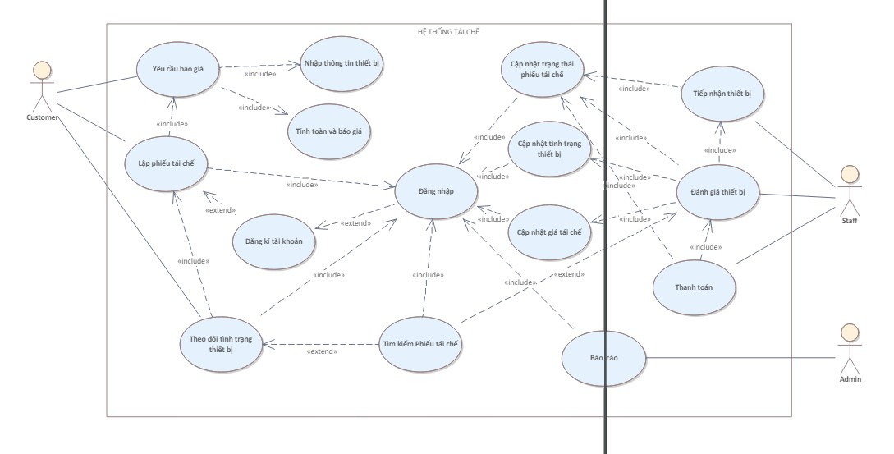

# 3. CLASS DIAGRAM

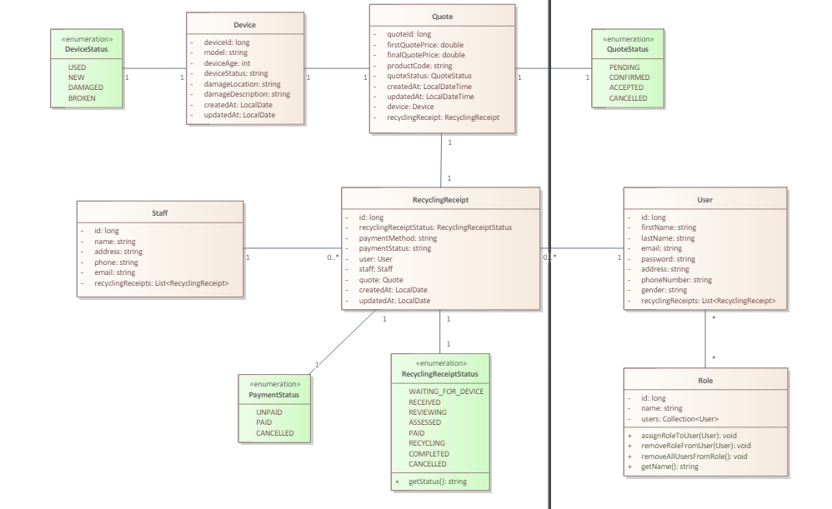

# 4. SYSTEM ARCHITECTURE

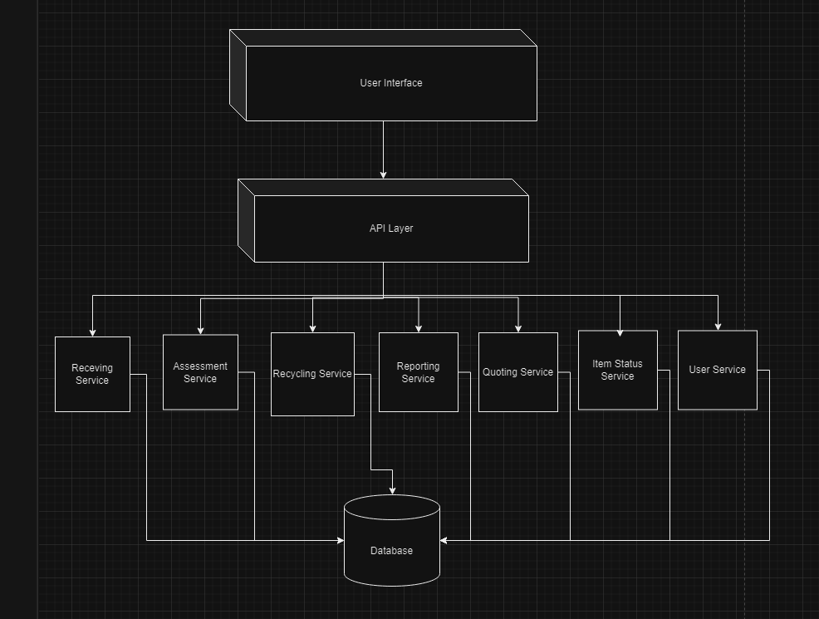

* ***Receving Service:*** Receiving old electronic devices from users or customers.
* ***Assessment Service:*** Assessing the condition and recyclability of old electronic devices.
* ***Recycling Service:*** Recycling materials from old electronic devices to reduce waste and resource usage.
* ***Reporting Service:*** Providing information and reports on specific activities, data, or events.
* ***Quoting Service:*** Providing information and estimates for the recycling or processing of old electronic devices.
* ***Item Status Service:*** Providing information on the status and location of electronic devices during the recycling process.
* ***User Service:*** Managing information and activities of users within the system.

Service-Based Architecture, particularly microservices, has its own advantages and disadvantages compared to other traditional software architectures such as monolithic, SOA (Service-Oriented Architecture), and module-based architecture. Below is a detailed comparison:

## 4.1 Advantages of Service-Based Architecture

### 4.1.1 Flexibility and Scalability:

* Independence: Each service can be developed, deployed, and scaled independently, enhancing flexibility.
* Scalability: Specific services can be scaled based on demand, rather than scaling the entire system.

### 4.1.2 Ease of Maintenance and Upgrades:

* Isolated Deployments: When an update or repair is needed for a service, only that service needs to be redeployed without affecting the entire system.
* Modularity: Separate services make it easier to manage and maintain different parts of the system.

### 4.1.3 Enhanced Fault Tolerance:

* Fault Isolation: Failures in one service do not necessarily disrupt the entire system. Other services can continue to operate normally.

### 4.1.4 Independent Development Teams:

* Autonomous Teams: Each development team can work independently on different services, improving efficiency and reducing development time.

### 4.1.5 Diverse Technologies:

* Polyglot Programming: Each service can be developed using the programming language and technology most suitable for its functionality, without being constrained by a single technology stack.

## 4.2 Disadvantages of Service-Based Architecture

### 4.2.1 Complexity:

* Management Overhead: Managing and coordinating multiple services requires more complex tools and processes.
* Service Communication: Managing communication between services involves dealing with issues such as latency, data consistency, and error handling.

### 4.2.2 Performance and Latency:

* Network Overhead: Communication between services over a network can result in higher latency compared to internal calls within a monolithic application.
* Performance: Deploying multiple services can lead to higher resource costs and requires performance optimization for each service.

### 4.2.3 Data Consistency:

* Data Management: Maintaining data consistency between services can become complex, especially with multiple databases.
* Transaction Management: Executing distributed transactions requires more complex techniques compared to transactions within a monolithic application.